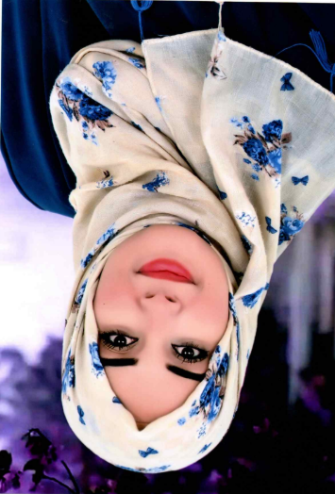 |  | moufida daizi  ArabicSenior Professor Above Rank / scientific researcher in Arabic civilization and linguistics
- Profile : a young motivated teacher with good experience not only in teaching but also on how to deal with students during their teenage and try so hard to make them understand what I’m teaching in the simpliest way possible… I really do love my job and my students, they inspired me to do reaserches and to try being the best version of an arabic teacher  - Skills : - computer proficiency  -in addition to arabic I speak french (C1)/ italian (A2)/english (B2)  -confidently crowd-speech  -working under pressure  -photography  - Personal info :  -date of birth : 23/08/1988  -material state : married  -nic number : 04595081  - Contact :  -phone number : +21693241142  -e-mail : daizimoufida70@gmail.com |  | EDUCATION  High school of makther “LTM”  2003 - 2007  Graduated from high school after being a literature student there and got my baccalaureate with honors  IPELSHT (The Preparatory Institute for Literary and Human Sciences Studies of Tunis)  2008 - 2010  After 2 years of preparation and learning Arabic literature I successfully passed the final exam to get into a teaching school and I proudly had the 6th rank  ENS (École normale supérieure / higher school of teachers)  2010-2013  Got my diploma in Arabic civilization with honors  FLAHM (faculté des lettres, des arts et des humanités de manouba/ faculty of literature, arts and humanities of manouba)  2022-2023  Scientific research master degree with honors  FLAHM (faculté des lettres, des arts et des humanités de manouba/ faculty of literature, arts and humanities of manouba)  2024-2026  2nd year PHD in arabic neurology linguistics  Work experiences  Tunisian Ministry of education : arabic teacher  2013–2025  12 years of teaching arabic language for all levels from 7th grade to baccalaureate with a pedagogical rank of 16.5/20  - 9 years of them were with baccalaureate in literature  Tunisian linguistic atlas project: permanent member  2023-2025  After my master thesis’s discussion I officially and proudly became a member of the tunisian linguistic atlas project  Semantic Research and Computational Linguistics Laboratory : member  2024–2025  As long as my PHD reaserch is a mix of art , technologies , literature and science it’s ordinary to be a part of laboratories of that kind  Being part of the correctors team in the final arabic exam for baccalaureate in literature  2014-2024

